

Procurement Plan ©
For [Project Name]

Document Control

Document Information
© | Information
Document Id | [Document Management System #]
Document Owner | [Owner Name]
Issue Date | [Date]
Last Saved Date | [Date]
File Name | [Name]

Document History
Version | Issue Date | Changes
[1.0] | [Date] | [Section, Page(s) and Text Revised]

Document Approvals
Role | Name | Signature© | Date
Project Sponsor

Project Review Group

Project Manager©

Quality Manager
(if applicable)

Procurement Manager
(if applicable)

Communications Manager
(if applicable)

Project Office Manager
(if applicable)

Table of Contents

Template Guide 1
1 Procurement Requirements 2
1.1 Requirements 2
1.2 Purpose 2
1.3 Justification 3
2 Market Research 4
2.1 Market Conditions 4
2.2 Available Products 4
3 Procurement Plan 5
3.1 Schedule 5
3.2 Assumptions 6
3.3 Risks 6
4 Tender Process 6
4.1 Overview 6
4.2 Procedures 6
4.3 Roles 6
4.4 Documents 6
5 Procurement Process 7
5.1 Overview 7
5.2 Procedures 7
5.3 Roles 7
5.4 Documents 7
6 Appendix 7

Template Guide

What is a Procurement Plan?

A Procurement Plan describes which products will be acquired from external suppliers to the project, as well as when and how they will be acquired. More specifically, the plan includes:
- A breakdown of the products to be acquired from external suppliers, including a detailed description of each product and the justification for procuring them externally rather than building / providing them internally
- An overview of the external supply market to provide confidence that the products do actually exist in the market and that suitable suppliers can readily provide the products within time and budget constraints
- A plan outlining the timeframes for acquiring the products
- A tender process describing how the preferred suppliers will be chosen
- A procurement process describing how the product will be acquired from the preferred supplier and how the supplier relationship will be managed to ensure continued delivery. ©

It is important to note that the term “Products” includes goods (e.g. computer hardware, raw materials and equipment) and services (e.g. raw labor, technical services, consultancy and management).

When to use a Procurement Plan

A Procurement Plan should be produced for any project which involves the acquisition of product from an external supplier. Whether it involves one or more products or suppliers, a clear plan for the acquisition of product should be documented in the form of a Procurement Plan. This document is formed early in the project lifecycle (during the Planning phase) and relies heavily on the definition of deliverables in the Project Plan and Quality Plan to determine which product should be acquired externally rather than within the organization.

Without a formal Procurement Plan in place, it will not be clear which product will be sourced externally, from whom and when. This may lead to procurement difficulties and hence increase the overall risk to the project. ©

How to use this template

This document provides a guide on the topics usually included in a Procurement Plan. Sections may be added, removed or redefined at your leisure to meet your particular business circumstance. Example tables, diagrams and charts have been added (where suitable) to provide further guidance on how to complete each relevant section.

Procurement Requirements

Identify the products to be sourced from outside the organization, the purpose of each product and the justification for procuring it as opposed to sourcing it internally.

Requirements
Describe the specific products and quantities to be sourced from the external market place as well as the budgeted expenditure for each product, using the following table:

ID | Product | Description© | Quantity | Budget
CH1 | Computer Hardware | Latest specification computer Intel PC including:  - Screen (19 inch monitor)  - Computer unit (latest Intel processor)  - Accessories (keyboard, mouse)  - Latest Windows Operating System  - MS Office software suite | Amount | $
RM1 | Raw Materials | Building construction materials, including:  - Wooden framing for walls  - Roofing materials  - Electrical cabling and switches | Amount | $
CS1 | Consultancy Services | General consultancy services to assist with the management of the project, including:  - Quality assurance and auditing  - Project office management  - Accounting services | Amount | $

Purpose
Describe the purpose of each product within the following table:

ID | Product | Purpose
CH1 | Computer Hardware | To enable project management and administrative staff to oversee the project by recording and tracking progress against project plans
RM1 | Raw Materials | To physically construct the deliverables to be produced by the project
CS1 | Consultancy Services | To provide confidence that the project will achieve the time, cost and quality targets through regular reviews and reporting

Justification
Provide sound reasoning as to why the above products must be acquired from external suppliers as opposed to from within the business, using the following table:

ID | Product | Justification©
CH1 | Computer Hardware | There are no available PCs within the business of a suitable specification to perform the required tasks
RM1 | Raw Materials | The business does not currently have sufficient spare raw materials to produce the project deliverable
CS1 | Consultancy Services | There are no human resources within the business suitably qualified to undertake the activities required

Market Research

Conducting market research is critical to ensuring that the right product is readily available in the market place at the right price. Questions such as "Which products are available?"; "Will they meet the requirement?"; and "Are suppliers able to deliver the product at the right price within the timescales needed?" are all questions which need to be answered before the Procurement Plan can be completed. Undertake a thorough market research exercise and document the results of the research program within the following section.

Market Conditions
Identify the various market conditions related to the supply of the products listed in the section above. The types of market conditions to be considered include:

- Political environment (Is it stable? Will influences in the exchange rate have a bearing on product pricing? Is change likely?)
- Technological trends (Will new technologies present new opportunities or threats?)
- Market segment (How many suppliers are in this particular market segment?). ©

Available Products
List a sample of the potential suppliers and currently available products to provide confidence that there are products available in the market place which will likely meet the requirement within the budget stated. Cross reference the supplier name, available product and current price with the product ID above, using the following table:

ID | Supplier Name | Supplier Product© | Price
CH1 | ABC Ltd | Intel PC, including:  Screen (19 inch monitor)  Computer unit (latest Intel processor)  Accessories (keyboard, mouse, CD reader) | $
RM1 | DEF Ltd | Building construction materials, including:  Wooden framing for walls  Roofing materials  Electrical cabling and switches | $
CS1 | XYZ Ltd | Consultancy services, including:  Quality assurance auditing  Project Office management  Accounting services | $

Procurement Plan

Schedule
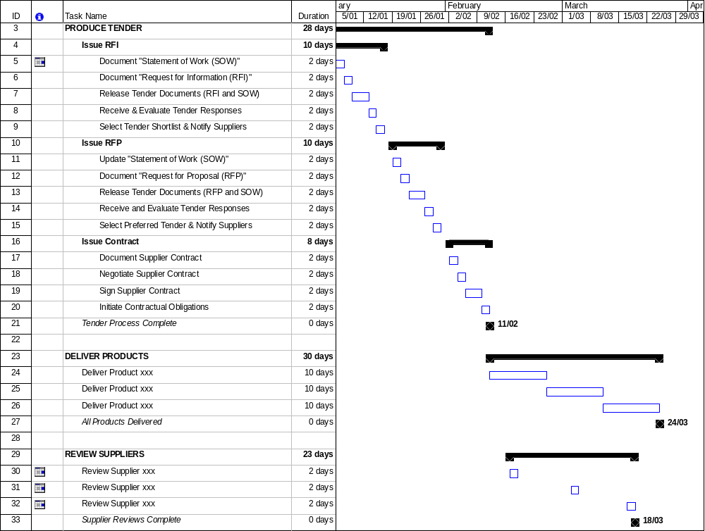
Schedule the activities required to complete the tender, deliver the required products and review the suppliers’ performance.

Assumptions
List any assumptions made during this Procurement Planning exercise. For example:

It is assumed that:

- The procurement requirements will not change
- There will be no changes to market pricing
- The pool of current suppliers will be available as required.

Risks
List any risks identified during this Procurement Planning exercise. For example:

- The procurement requirements may not be defined in sufficient detail to provide potential suppliers with an in-depth understanding of the project requirement
- The methods undertaken to review supplier performance may not provide adequate confidence that the suppliers will meet the specified procurement requirements
- The resource allocated to undertake the supplier reviews may not be appropriately skilled to complete the activity as required. ©

Tender Process

Depending on the size of the project, either summarize the Tender Management Process as provided below or reference a more detailed Tender Management Process document.
(NB Refer to the Method123 ‘Tender Management Process’ for a detailed example).

Overview
Provide an overview of the process undertaken to select preferred suppliers for the acquisition of product for the project (i.e. the ‘Tender Process').

Procedures
Provide a diagram highlighting the procedures involved with creating and releasing tenders, selecting preferred suppliers and forming contractual relationships with preferred suppliers. Describe how each procedure will be undertaken.

Roles
Define the roles and responsibilities of all resources involved with the selection of preferred external suppliers.

Documents
List any other documentation used when undertaking the tendering process. For example: Statement of Work (SOW), Request for Information (RFI), Request for Proposal (RFP), Tender Register.

Procurement Process

Depending on the size of the project, either summarize the Procurement Process as provided below or reference a more detailed Procurement Management Process document. (NB Refer to the Method123 ‘Procurement Management Process’ for a detailed example).

Overview
Provide an overview of procurement management and the general process for acquiring products (goods and services) from external suppliers for the benefit of the project.

Procedures
Provide a diagram highlighting the procedures involved with managing the ordering, receipt, review and approval of products from suppliers, as well as the overall management of supplier relationships, to ensure continued customer service. Describe how each procedure will be undertaken.

Roles
Define the roles and responsibilities of all resources involved with the procurement of product from external suppliers.

Documents
List any other documentation used when purchasing product for the project (e.g. Procurement Register, Purchase Order Form).

Appendix

Attach any documentation you believe is relevant to the Procurement Plan, including:
- Project documentation (e.g. Business Case, Feasibility Study, Terms of Reference, Project Plan, Resource Plan, Financial Plan or Quality Plan)
- Requirements Analysis or Needs Analysis documentation
- Market Research materials
- Other relevant information or correspondence. ©

